Welcome to Healing Yoga for Cancer Survivorship, a gentle yoga program specifically designed to build breath and body awareness, increase energy, circulation and lymphatic drainage, reduce anxiety, fatigue, sleeplessness, constipation and pain for those going through cancer treatment. The sequence provides instruction on intention setting that is done at the beginning of the session; simple sound practices to focus your attention and bring you more closely into contact with your center; mudra or hand gestures to calm the mind and emotions; breathing techniques to increase prana, the vital force in your body that is helpful for healing; and a progression of yoga postures from a reclining position to sitting to kneeling to standing that will move all the joints in the body; we will finish with restorative yoga and meditation techniques that will refresh the body, mind and spirit.
Feel free to practice the entire sequence or only the sections that feel appropriate for you on any particular day. Try to practice for a few minutes each day to give your body and mind the time and space to heal. It is best to practice with a yoga mat on a hard floor surface. The yoga mat provides both cushion and traction for your feet during the standing postures. You may also need a folded blanket for some of the postures, especially for the head during the reclining postures and to sit on to make sitting on the floor more comfortable. Fold the blanket so that you sit on the long folded edge and sit high enough so that the knees fall at or below the hip bones. If sitting on the floor is not comfortable, please feel free to sit in a chair instead.
PLEASE BE CAUTIOUS: Be sure to stay mindful of the body and breath throughout the practice, and only do the movements in a range of motion that is completely comfortable and in a way that your breath stays normal and fluid. If a movement or practice causes discomfort, pain, dizziness, nausea or breathlessness, please stop immediately and rest for a few moments. Listen to the cues and messages from your body before deciding if it would be appropriate to move on to a more gentle technique or if you need to stop practicing for today.

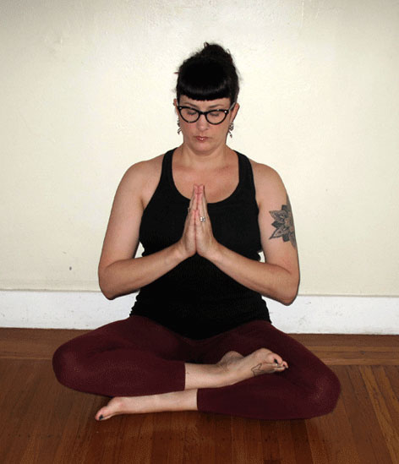
Namaste’
May the light in you recognize the light in me and let us realize that we are one.
SETTING YOUR INTENTION
We will begin with an intention setting meditation which guides you through setting a sankalpa (an intention or resolve) for your practice. Once you create your intention, continue to use it before your practice each day. You will repeat the sankalpa three times silently at the beginning of your practice and then call it to mind again at the end of your practice. This repetition plants a seed for self-transformation deep within your mind to assist you on your path towards healing. At some point in the future, you may feel the need to change the sankalpa if it has come to fruition or you are not resonating with it any longer. Then it would be appropriate for you to go through this meditation again.
Begin sitting in a comfortable seated position with the palms resting together at the heart. Feel the breath gently directed into the chest which will encourage your deepest wish for self-transformation to arise. Bring to mind the current challenges that you are facing. Without dwelling on the details, recognize that all challenges are opportunities for personal growth and healing. Perhaps your current challenges have already set the stage for transformation in your life. Continue to visualize this challenging situation and hold it within the space of the heart, releasing any feelings of judgment or blame if they arise.
Begin to visualize the best possible outcome for the challenges you are facing. If any thoughts of doubt begin to arise, redirect the mind towards receptivity and the positive resolution of your current situation. Whatever steps need to be taken, imagine taking them with self-confidence bringing this outcome into reality.
Trust that you have the strength, courage and ability to bring the imagined positive outcome into reality. Be confident that you can create your own reality based on your visualization. Allow your intention to coalesce into a short simple statement phrased in the present tense beginning with the words "I am ...". State it silently three times. Trust that your sankalpa will manifest with patience and repetition and repeat it mentally before each yoga practice.. Take a few more breaths to firmly implant this heartfelt wish into your consciousness.
Stating Your Intention
- During the first yoga session you will create an intention for your yoga practice. Each time before you practice, sit comfortably with the eyes closed and bring to mind this resolve, state it silently three times with your full awareness.
- You are welcome to write you intention down here if you choose:

My Intention:

________________________________________________
________________________________________________
CHANTING
Creating sound is a wonderful way to center the body and mind. It brings awareness to different parts of the body through the vibration of the voice. The vowel spiral uses different letters to create vibration and sensation that spirals from the heart center outward - to the throat then spiraling down to the belly, back up to the forehead, around and down to the base of the body, back up to the crown of the head and back to the heart.
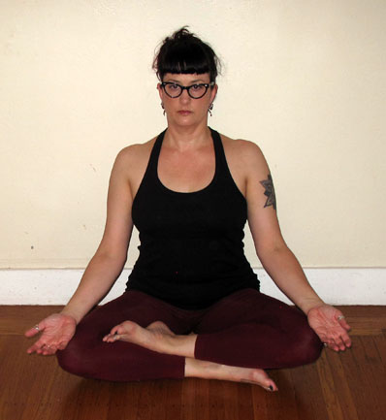 | Vowel Spiral A-E-I-O-U-M  - Begin in a comfortable seated position (you may sit in a chair if needed).Take a few breaths into the lower belly and exhale naturally through the nose. When you are ready to begin, chant the sounds at a natural speaking pitch. You may also place your hand over the areas of the body where the vibration is strongest.  - AHH at the Heart  - AAA at the Throat  - OOO at the Belly (lips very round)  - EEE in the Head (smile wide with the mouth)  - UUU at the Tailbone  - MMM at the Crown  - Repeat AHH at the Heart  - Intended Intended Benefits: Each vowel resonates within your body at different levels bringing awareness and relaxation.

MUDRAS
Mudras are hand gestures that redirect energy and awareness into the body to create specific physical or emotional shifts. Like you would tune a radio to a certain frequency to listen to a particular type of music, you create patterns with the fingers to elicit a particular response in the body. You can practice mudras any time you need to feel a sense of connection to your center.
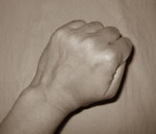 | Adhi Mudra  - Begin in a comfortable seated position (you may also sit in a chair if needed). Make a soft fist with the thumb tucked inside. Turn palms down and rest the hands on the knees.  - Intended Benefits: Creates a sense of grounding and reduces anxiety
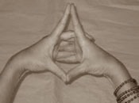 | Uttarabodhi Mudra  - Clasp hands together and press index fingers together and thumbs together and open the center of the palms.  - Variation I: Hold hands in front of belly with the sides of the thumbs, heels of the hands and sides of the pinkie fingers against abdomen. Creates a sense of self-nurturance.  - Variation II: Hold hands in front of heart with the sides of the index fingers and sides of the thumbs against the sternum. Activates the thymus gland to increase immunity.
MUDRAS
This 4-part breath, mudra and mantra meditation is especially helpful for fostering emotional well-being. It highlights the four natural parts of the breath cycle with a mudra and mantra to allow the mind to be completely absorbed in the practice and can be used whenever you feel the need to reconnect with the life giving energy that each breath offers and with the trust inherent in our true nature.
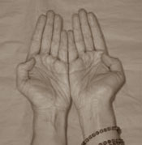 | Avhana Mudra  - Begin in a comfortable seated position (you may also sit in a chair if needed). Turn the palms up touching the pinkie side of the hands together. Press the bent thumbs into base of index finger and keep the other fingers close together.  - As you inhale, say mentally "I accept" and draw the hands toward the body.  - Intended Benefits: Increases ability to receive help from others from others
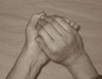 | Samputa Mudra  - Cup hands right over left creating a hollow space between the palms.  - During the pause after the inhale, say mentally "I am grateful".  - Intended Benefits: Acknowledges the gifts you carry within
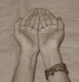 | Pushpanjali Mudra  - Cup hands with little and ring fingertips together creating a offering bowl shape.  - As you exhale, say mentally "I give" and move hands away from the body.  - Intended Benefits: Encourages compassion, generosity, giving
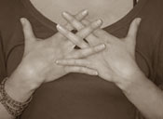 | Vajrapradama Mudra  - Clasp fingers together and open the palms toward heart; point thumbs upwards and hold the hands a few inches away from the heart.  - During the pause after the exhale, say mentally "I trust"  - Intended Benefits: Builds confidence, security, and trust
RECLINING YOGA
This gentle reclining yoga series can be used as a warm-up for the other yoga postures in this sequence or as a stand-alone practice when you are feeling fatigued. As you move through the postures, follow the pace of your breath; be sure to only move in a comfortable range of motion and for a comfortable length of time. If you become light-headed or nauseated while you are practicing, stop and rest with the knees bent and the feet on the floor or roll to the side for a few moments before continuing.
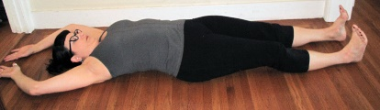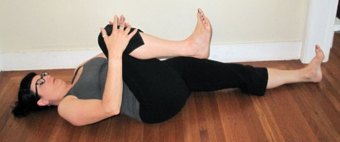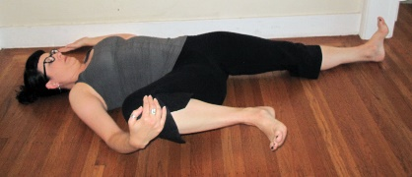
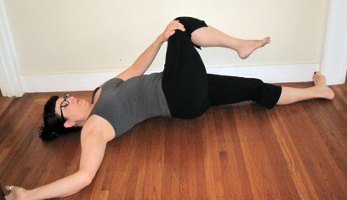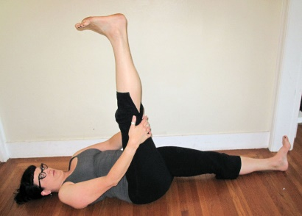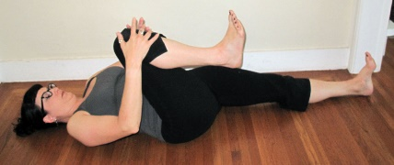
Floor Vinyasa
- Begin lying on the back with the legs straight.
- Exhale and draw the right knee into the chest holding with the right hand.
- Inhale and draw the right knee out to right as you reach the left arm to the floor beside the shoulder.
- Exhale and pass the knee to the left hand and cross the knee over to left coming into a twist.
- Inhale and roll back to the center, extend the right leg up, clasping the hands behind the thigh.
- Exhale and draw the right knee into the chest.
- Inhale and extend the leg to the floor and raise the arms overhead. If it is difficult to raise the arms overhead, rest them beside the body.
- Exhale repeat sequence with left leg.
- Repeat with the breath at least 5 times.
- Intended Benefits: Opens the major joints of the lower body and stretches the legs, hips, low back and shoulders
Windshield Wipers
- Bend the knees and place the feet on the floor as wide as your mat. On an inhalation lower knees to the left about half way to the floor. Exhale and engage belly as you bring knees back to the center. Inhale as you repeat to the right side, and exhale back to the center.
- Repeat alternately with the breath 5 times per side.
- Intended Benefits: Broadens back of pelvis, stretches outside of legs, gently compresses the abdominal organs
ARM POSITION VARIATIONS
There are a few different arm positions that you may choose from depending on how flexible the chest and shoulders are and depending on whether there is a port, surgery site or other difficult with raising your arms overhead. Please only go as far into each movement as it is comfortable for you to move today.
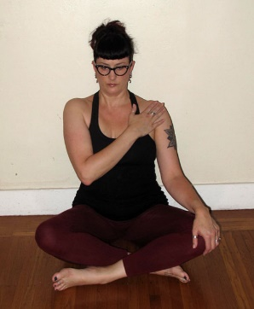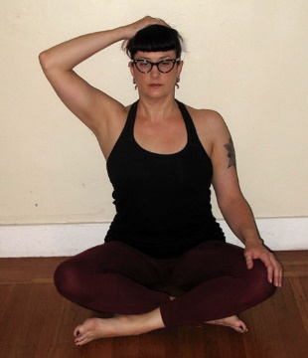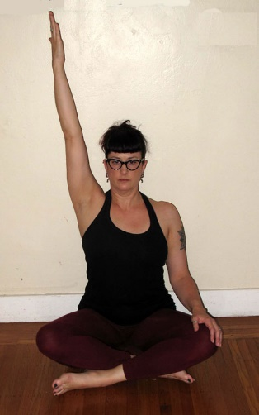
Arm Positions for One Arm
- If instruction is given to bring one arm over the head and it is difficult for you to do so, you may try the following variations:
- Hand to Shoulder: Try reaching the hand to the opposite shoulder.
- Hand to Head: Try placing the hand on the top of your head with the elbow out to the side.
- Arm Overhead: If you have full range of motion, you can reach the arm all the way over the head with the palm facing inwards.
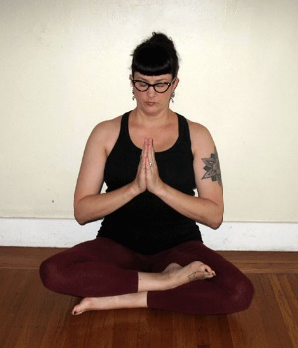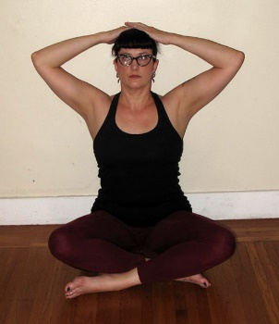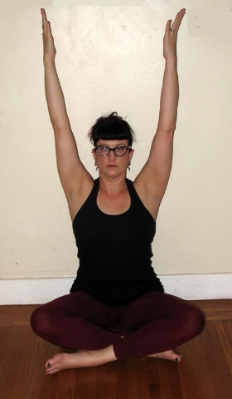
Arm Positions with Both Arms
- If instruction is given to bring both arms over the head and it is difficult for you to do so, you may try the following variations:
- Hands to Heart: Try touching the palms together at the heart.
- Hands to Head: Try placing the hands on the top of your head with the elbows out to the side.
- Arms Overhead: If you have full range of motion, you can reach the arms all the way over the head with the palms facing inwards.

SEATED YOGA
This gentle seated yoga series will increase movement and range of motion in the spine and shoulders. This increased movement will assist with increasing breath capacity and moving lymph through the nodes and vessels in the chest and torso. When moving the arms it is important to only stretch to a comfortable degree, especially if there are surgery sites or ports in the chest, alternate arm positions will be given so be sure to choose what is comfortable for your body today. Continue to follow the pace of your breath, it is a barometer of how you are feeling in each pose. If you find yourself holding the breath, try again a bit more gently. If you become light-headed or nauseated, stop and rest in a simple cross- legged position for a few moments before continuing.
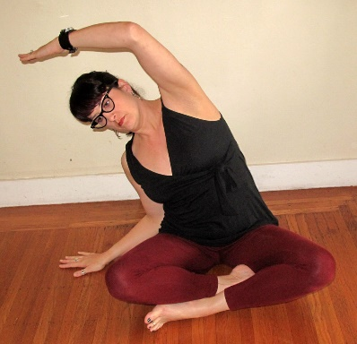 | Seated Lateral Bend  - Begin in a comfortable seated position (you may sit in a chair if needed). Reach the crown of the head up towards the ceiling. As you inhale side bend to the right and bring the left hand to the right shoulder, or bring the left hand to the top of the head, or reach the left arm overhead with the palm facing down. The right hand is on the floor beside the hip with the elbow bent towards the body to keep the right shoulder relaxed. Keep both sit bones grounded into the floor. Exhale return to center.  - Repeat to both sides with the breath 5 times.  - Intended Benefits: Opens side ribs and facilitates breath and lymph movement throughout the torso.
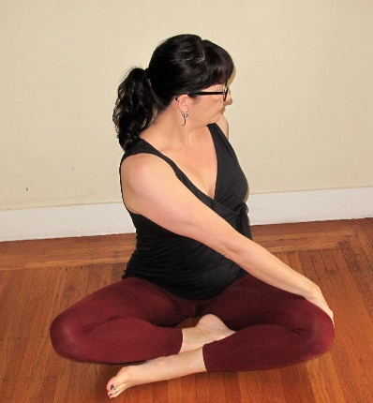 | Seated Twist  - Begin in a comfortable seated position (you may sit in a chair if needed). Reach the crown of the head up towards the ceiling. As you inhale, draw both hands together at the heart, or to the top of the head, or raise both arms straight up overhead to create length in the sides of the torso. Exhale and twist our belly, ribs and chest to the right, bring the left hand to the right knee, the right hand on the floor behind you. Inhale and return to the center with the arms in your chosen position. Exhale and repeat to the left (shown).  - Repeat to both sides with the breath 5 times.  - Intended Benefits: Opens the ribs, massages the organs facilitates breath and lymph movement throughout the torso.
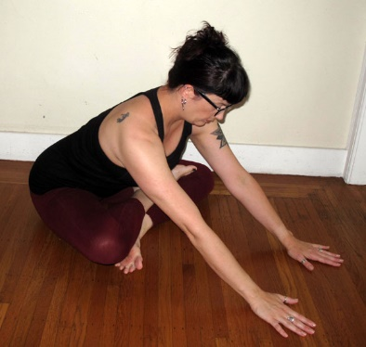 | Seated Forward Bend  - Begin in a comfortable seated position (you may sit in a chair if needed). Reach the crown of the head up towards the ceiling. As you exhale reach the arms forward and lean the torso forward from the hips. Keep the lower back long as the navel reaches forward. Use the arms to support the body and come forward as far as feels comfortable, to the palms, or even to the forearms. Keep the pelvis grounded and breathe gently into the stretch. Hold for at least 5 breaths.  - Intended Benefits: Stretches the thighs, groins, hips and low back.
KNEELING YOGA
This gentle kneeling yoga series will deepen movement in the spine, shoulders and hips, increase breath capacity and help to move lymph through the nodes and vessels in the chest and torso. When moving the arms it is important to only stretch to a comfortable degree, especially if there are surgery sites or ports in the chest, alternate arm positions will be given so be sure to choose what is comfortable for your body today. Continue to follow the pace of your breath; it is a barometer of how you are feeling in each pose. If you find yourself holding the breath, try again a bit more gently. If you become light-headed or nauseated, stop and rest in a simple cross- legged position for a few moments before continuing.
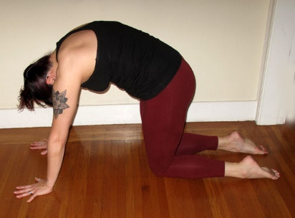  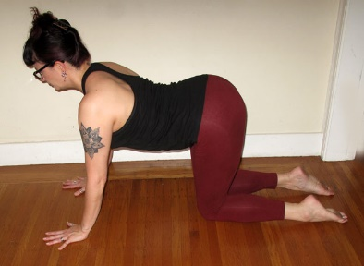 | Cat/Cow  - Begin kneeling with the hands under the shoulders, knees under the hips with the toes pointed. As you inhale, lengthen the spine from the crown to the tailbone.  - Cat: As you exhale draw the belly in, round the back and drop the head and tail bone towards the floor.  - Cow: As you inhale arch the back lifting the sternum forward and the tailbone up towards the ceiling, pulling the shoulder blades down the back.  - Repeat at least 5 times with the breath.  - Intended Benefits: Massages the internal organs, stretches the muscles along the spine, assists with lymphatic drainage
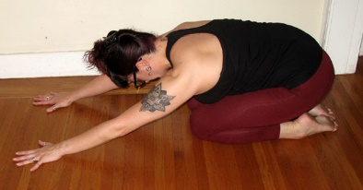  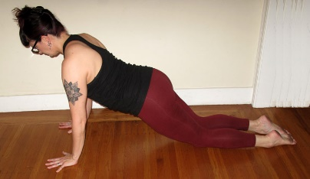  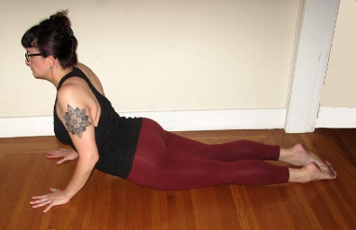 | Extended Childs Pose to Cobra  - Extended Childs Pose: From a kneeling position, step the hands forward a few inches and then exhale into Childs pose with the arms extended overhead on the floor. Only go back as far as your knees will comfortably allow.  - Knee Plank: As you inhale move the torso forward bringing the shoulders over the wrists and the torso in a plank position. Then exhale back into Extended Childs Pose.  - Cobra: If it is available to you, you may also bring the torso all the way forward into a gentle back bend with the elbows bent, the heart lifting and the pelvis close to the floor. Then exhale back into Extended Childs Pose.  - Repeat at least 5 times with the breath.  - Intended Benefits: Stretches and strengthens the front and back of body, assists with lymphatic drainage and constipation.

KNEELING YOGA
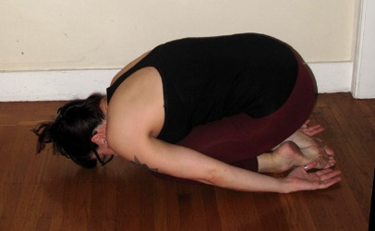  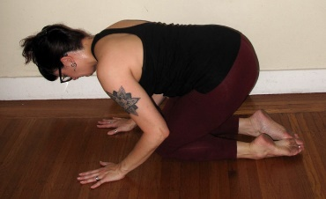  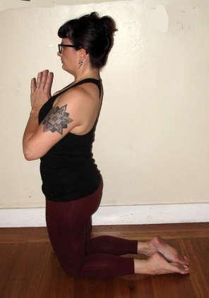 | Childs Pose to Extended Hero  - Childs Pose: From a kneeling position, exhale and sit back on the heels into Childs pose with hands beside the feet or place palms in front of the knees for more support.  - Alternate Childs Pose: Only go back as far as your knees will comfortably allow. You may need to place the hands in front of you and lower yourself down slowly, especially if there is knee pain or any nausea.  - Extended Hero: As you inhale, lift the chest, press the pelvis forward and raise hands to the heart, hands to the head or the arms straight overhead.  - Then exhale back into Childs pose by sitting back on the heels, folding the torso forward and bringing hands to floor beside the feet or in front of the knees.  - Repeat at least 5 times with the breath.  - Intended Benefits: Stretches and strengthens the torso, assists with lymphatic drainage and constipation.
STANDING YOGA
This simple standing series is perfect for days when you are feeling more energetic and will build strength in the shoulders, legs, hips and back. The focus continues to be on creating movement for lymphatic drainage, and on increasing focus and balance.
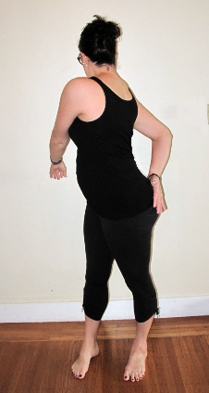 | Ganeshasana  - Stand with the feet slightly wider than hips width apart. Begin to gently swing the arms around the body loosely as you twist the torso right and left. You may choose to bend the left knee as you are turning to the right if that is more comfortable. Close the eyes if the movement makes you dizzy.  - Repeat for up to 1 minute.  - Intended Benefits: Encourages lymph to move throughout the body
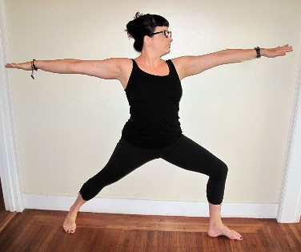  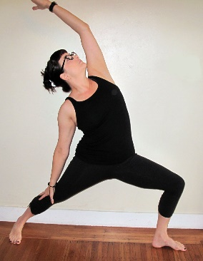 | Warrior II Series  - Stand with feet wide apart.  - Turn the right foot out 90 degrees and the left heel back about two inches so that the right knee points towards the right toes and the pelvis to the left corner of your mat.  - Inhale and bring hands to hips or raise arms up to shoulder’s height  - Exhale and bend the right knee over right ankle  - Inhale raise right hand to the head or the right arm overhead as you reach the left hand towards back thigh.  - Exhale return arms to parallel to floor  - Inhale and straighten the right knee  - Exhale and release arms to the sides  - Repeat with the breath 3-5 times per side.  - Intended Benefits: Strengthens legs and torso, stretches belly and back, increases circulation, articulates work in feet.
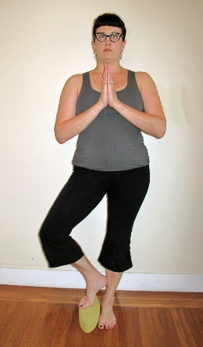 | Tree Pose  - Stand with block between feet. Lift right foot onto block and turn leg out until heel rests on inside of left ankle. Keep hips level and bring hands to heart.  - Keep the entire left foot in contact with the floor, pressing especially into the ball of the big toe. Find something to focus on that is at eye level or lower to allow your eyes and mind to quiet, this will help your balance and your focus.  - Hold for 5-10 breaths per side and come down with control.  - Intended Benefits: Strengthens legs and improves balance.
BREATHING PRACTICES
Bringing conscious awareness to the natural breathing process can have a profoundly relaxing and healing effect on the mind and body. We will practice three techniques here that can be done after your yoga practice or at any time throughout the day; alternate nostril breathing which balances the work of the nervous system, belly breathing which creates a state of peace and calm, and exhale retention which further releases stress and tension.
Alternate Nostril Breathing
- Begin in a comfortable seated position (you may also sit in a chair if needed). Use the right hand and close the right nostril with thumb. Breathe in through the left nostril, the change nostrils by closing the left nostril with the ring finger and breathe out through the right nostril. Breathe back in through the right nostril, then change the fingers again and breathe out through the left nostril.
- Try to hold the hand directly in front of the face so that you do not have to turn the head.
- Practice for up to 10 rounds, increasing the number of rounds gently as your comfort level allows.
- Intended Benefits: Balances the sympathetic nervous system (fight or flight) and the parasympathetic nervous system (rest and digest), increases communication between the right and left hemispheres of the brain.
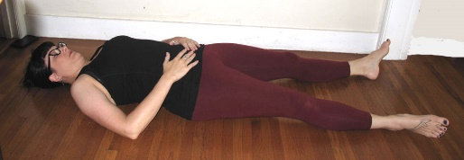 | Belly Breathing  - Lay on the back with support under the head and knees if needed, close eyes and feel the breath moving in and out of your nostrils.  - Place the hands on the lower belly. Inhale and feel the fullness in the belly, exhale and feel the surrender in the belly.  - Practice for up to 5 minutes.  - Intended Benefits: Calms the nervous system, grounds the emotions, and relaxes the body.
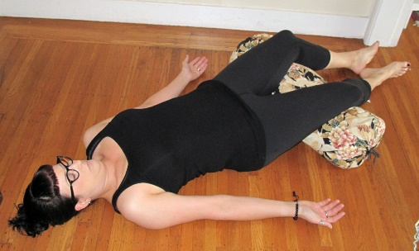 | Exhale Retention  - Lay on the back with support under the head and knees if needed, close eyes and feel the breath moving in and out of your nostrils. Rest the hands on the floor with the palms facing upwards.  - Inhale into the belly and exhale slowly and completely, extending the length of the exhalation slightly. Begin to rest in the pause after the end of the exhalation for a moment before breathing in. Long slow inhale, longer slower exhale and pause.  - Practice for up to 5 minutes.  - Intended Benefits: Calms the nervous system, grounds the emotions, and relaxes the body.
RESTORATIVE YOGA
Restorative yoga can complete a yoga practice or be done on days when you are highly fatigued and need a few minutes to reset the body and mind. These two postures are mild inversions that provide a change in our perspective to gravity and encourage deeper breathing, energy absorption and relaxation. Find a piece of furniture in your home like a soft chair, sofa seat or ottoman.
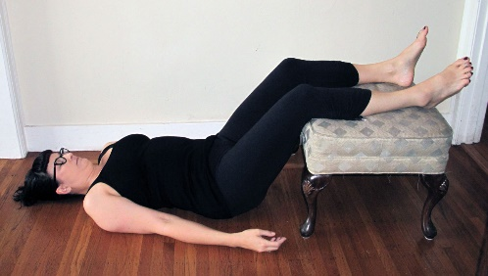 | Legs in the Chair  - Lay on the back with the legs in the seat. If you are using a hard piece of furniture, be sure to place a folded blanket between your calves and the surface. You may also wish to use a folded blanket for a pillow. Place the arms slightly away from sides with the palms facing up  - Rest for at least 10 minutes.  - Intended Benefits: Induces relaxation response, reduces edema in the legs and feet, relaxes lower back
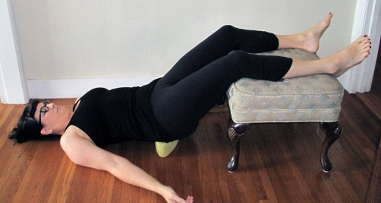 | Instant Maui  - Lay on the back with feet on the edge of the seat. Press down in the feet and lift the pelvis off the floor and place a block or a folded blanket under the back of your pelvis. The prop should be between the waistband of your pants and the tailbone. If it is too high or too low it will not feel comfortable so find that sweet spot where your sacrum parallel to the floor. Rest the arms slightly away from sides with the palms facing up. If the hips are elevated, it is best not to use a pillow for the head.  - The difference between Legs in the Chair and Instant Maui is that in this posture, your pelvis is elevated slightly above the heart so the effect is slightly stronger.  - Rest for at least 10 minutes.  - Intended Benefits: Induces relaxation response, reduces edema in the legs and feet, relaxes lower back  - Contraindications: High blood pressure, nausea

BODY SCAN
The Body Scan is a relaxation technique that brings gentle awareness to all parts of the body. It systematically relaxes the mind and the body at the same time and may be a helpful tool for healing and relaxation. It can also be used in bed on nights when sleep is elusive.

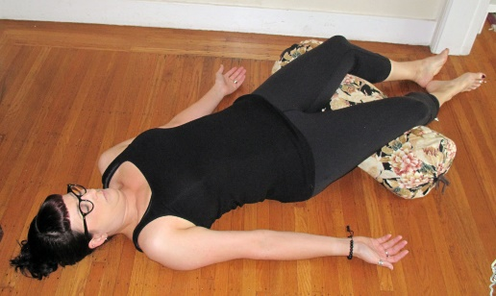 | Body Scan  - Lay comfortably on the back with support under the head and knees if needed. As you hear the body parts named, say the name to yourself and bring all of your awareness into each body part noticing the movement form one part to the next..  - Right hand thumb, 1st finger, 2nd finger, 3rd finger, 4th finger, palm of the hand, back of the hand, wrist, forearm, elbow, upper arm, right shoulder, armpit, chest, waist, hip, groin, buttock, thigh, knee, calf, ankle, heel, sole of the foot, top of the foot, right big toe, 2nd toe, 3rd toe, 4th toe, 5th toe.  - Repeat on the left side of the body.  - Top of the head, forehead, right temple, left temple, right ear, left ear, right cheek, left cheek, right eyebrow, left eyebrow, the eyebrow center, right eye, left eye, right nostril, left nostril, the whole nose, upper lip, lower lip, chin, jaw, throat, right collarbone, left collarbone, right chest, left chest, the heart center, upper abdomen, navel, lower abdomen, right groin, left groin, the pelvic floor, tailbone, sacrum, right buttock, left buttock, the entire spine, from the tailbone to the base of the skull, right shoulder blade, left shoulder blade, back of the neck, back of the head, crown of the head.  - Whole right arm, the whole left arm, both arms together, the whole right leg, the whole left leg, both legs together, the entire torso, the face, the head, the body, the whole body, your entire body.

FINAL RELAXATION
It is important to give yourself a few minutes at the end of your practice to rest in stillness and silence so that the gifts of the practice can be fully integrated into your body and mind. You may stay in the Body Scan posture and rest for as long as you like but be sure to rest for at least 5 minutes. Feel free to set a timer if you are concerned that you might fall asleep.

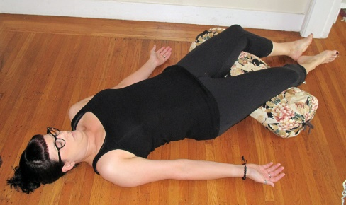 | Relaxation Pose  - Lay on the back with legs straight and feet relaxed to sides. Move arms away from sides slightly and turn palms to face the ceiling. You may use support under the knees for low back pain; and a folded blanket under the head if needed.  - Rest at least 5 minutes.  - Intended Benefits: Allows for integration of mind and body after asana practice, promotes restful awareness

